Lesson 15: Answer Key

Part 2 Key: Cheerleading Headgear Assessment

Scoring Guidance. The elements described below would be considered an exemplary response at this point in the unit. These are shown as purple text or in purple diagrams below the related question. In some cases different elements of the response are identified with a separate + symbol These +’s are not meant to be all inclusive; they are suggestions for what you may see your students include.

If several of the ideas marked with a + are missing from a student’s response, this may indicate the student has not mastered the science ideas or that the student may be struggling to bring those ideas together in a written explanation or model. Additional probing of their thinking can provide insight about whether the student is struggling with a science practice or science idea, or both. If all or almost all of the ideas marked with a + are present in a student’s response, this may indicate the student has mastered the science ideas and is able to use them in a written explanation or explanatory model.

Part 2: Designing an Optimal Solution (20 min)

Here are three different headgear devices used for cheerleading that you reviewed in part 1 of this assessment.
 | 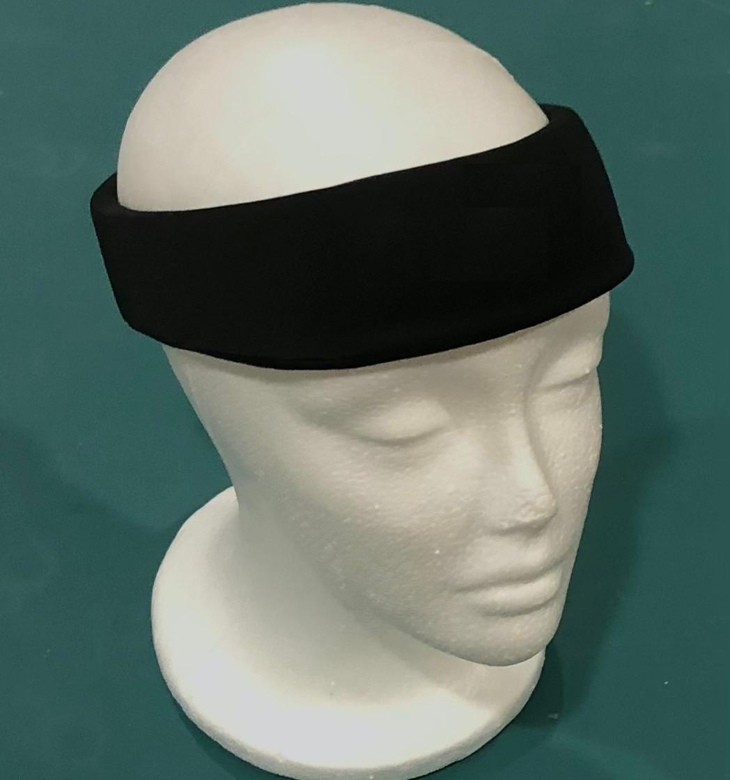 | 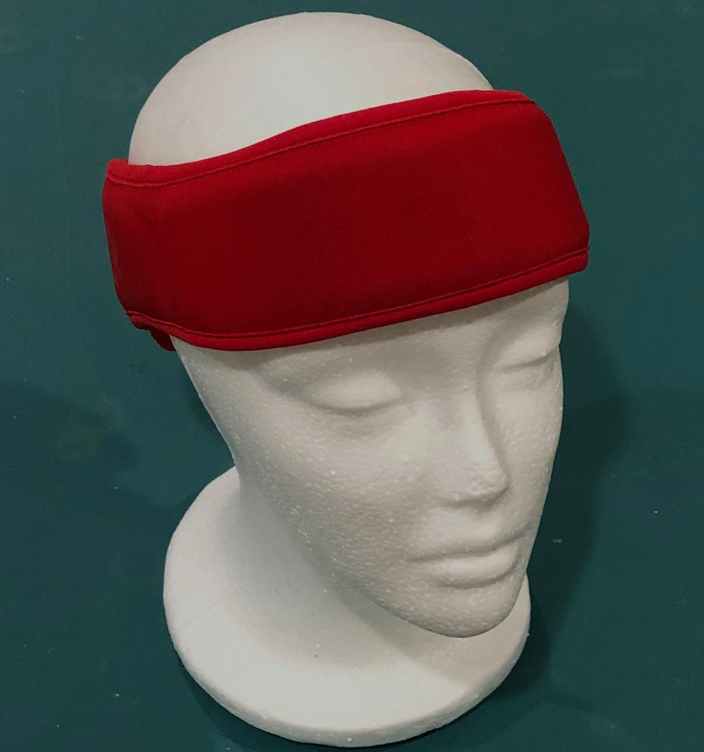
  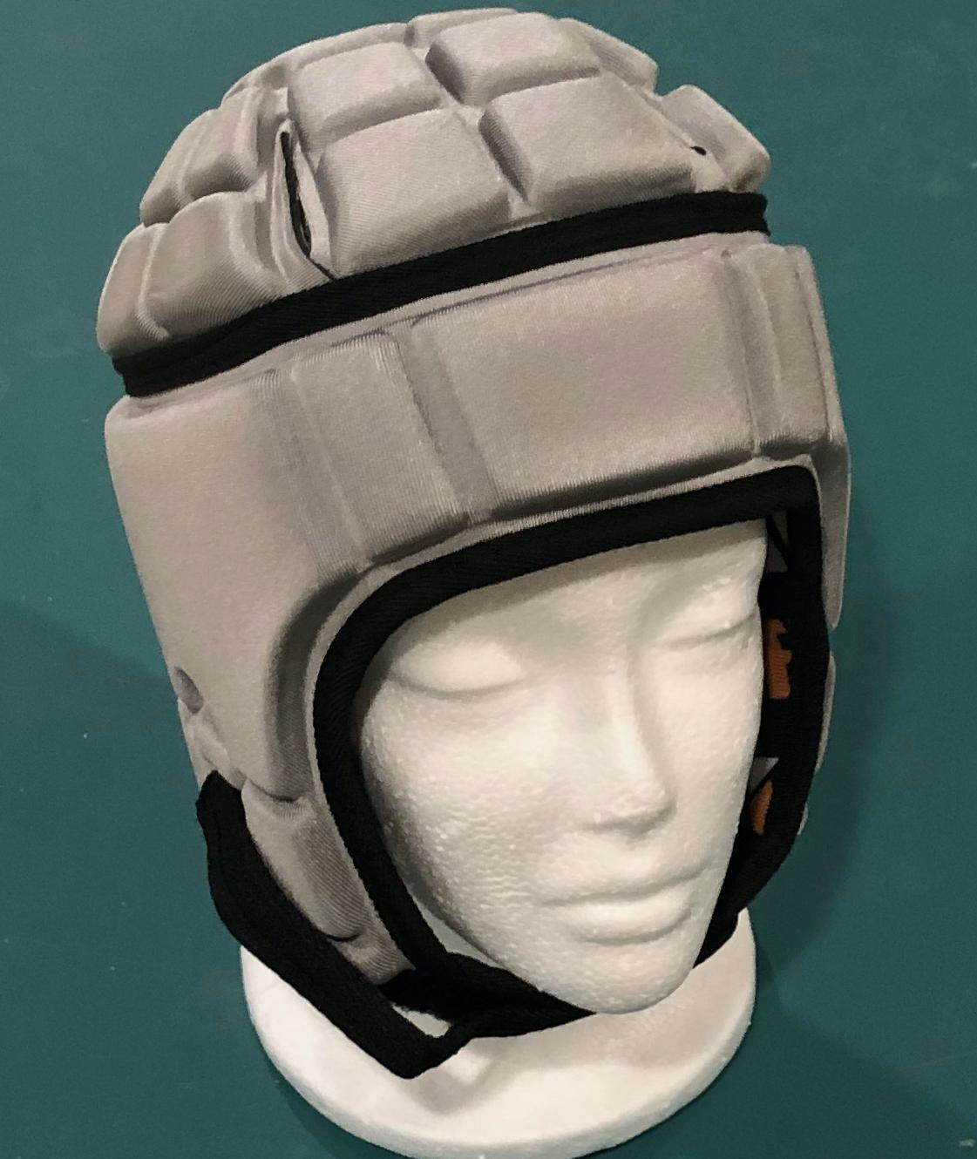
Design #1 | Design #2 | Design #3

These headgear devices were initially designed for other sports and then later people started using them for cheerleading. In competitions, cheerleading teams can earn points for more-advanced stunts and showmanship. The higher and more complex the throws and gymnastics, the more potential points can be earned by a team. Teams are also given points for engaging the crowd and overall appearance of the team.

Your task is to create an optimal headgear design for a cheerleader to wear in a competition. Complete the prompts below to describe your design choices.

Considerations for design

1. What is the purpose of the design? What criteria does the headgear you design need to meet?

+ Purpose of the design is to provide protection to the head.

Criteria
+ Needs to have materials that have protective properties
+ ability to deform
+ space for air
+ thickness and shape optimized for the design solution

2. Pick one stakeholder who will be affected by your design and design with that person in mind.
- Who is the stakeholder you are designing for?
- What constraints do you anticipate your stakeholder will bring to your design? List at least 3 constraints that you think a helmet designer would have to consider.

Students should list a stakeholder who is relevant to the scenario. This stakeholder should be someone who either uses the design, benefits from the design, or is impacted by the design.
Potential constraints
+ size of helmet
+ amount of the head the helmet covers
+ thickness of helmet
+ any aesthetic constraints
+ price
+ Students may list additional constraints. All applicable and reasonable constraints are acceptable.

Your design
3. Use words and pictures to show the structure of your design solution. In your design solution, make sure to label the different parts and materials used in the structure. Draw the proposed design on, over, and around the 2 views of the head shown below.

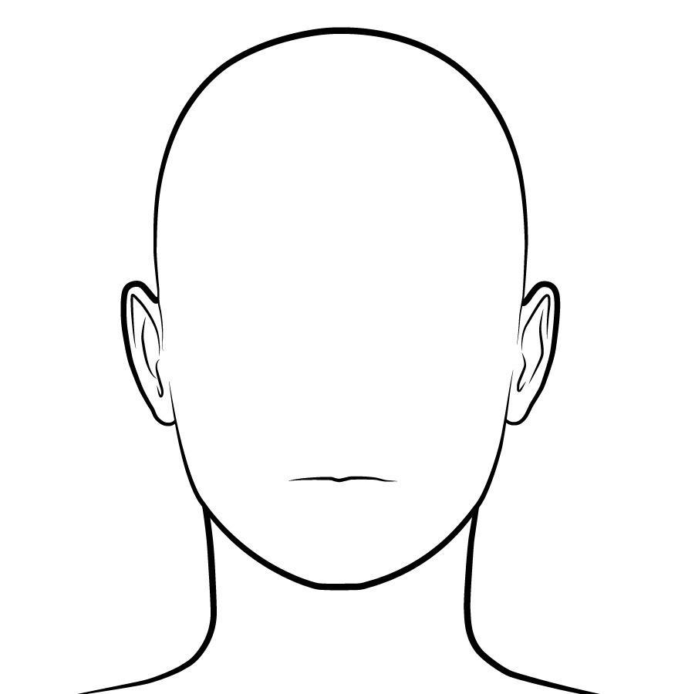 | 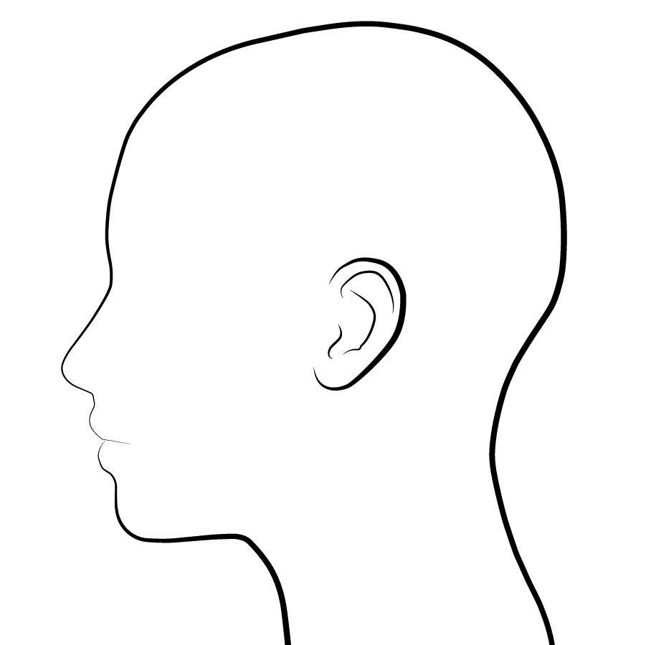

+ Students should draw their protective designs on the two outlines of heads.
+ Students should label the parts.
+ Students should show the different materials.
+ Students drawings should show the coverage area of the protection device.

4. Explain how the materials in your design in #3 will function to reduce peak forces on a team member’s brain in a collision. Describe how any smaller-scale structures (small and microscopic) that make up your materials help contribute to their function.

Student arguments should include how the materials will
+ have smaller pieces, layers, and sections of solid matter in them and have space for air to allow for the deformation of that solid matter.
+ deform over that space when a force is applied, leading to an increase in contact time and therefore a decrease in strength of forces.
+ optional: distribute the force over a greater surface area.

5. Write an argument for why your design solution is optimal and meets the needs of your stakeholder. If you made trade-offs, discuss what trade-offs you made and why. [As an alternative to writing your argument, you can use this space to prepare to present your explanation orally instead. Think about any imagery (diagrams, pictures, drawings) you want to include in your presentation and how you will convey all the components of your design solution (why it is optimal and meets the stakeholder needs). If you choose this route, make a plan with your teacher for when you can present your explanation.]

Optimal design solution argument
+ Look for students to make direct connections among the potential criteria constraints from question 2.
+ Students should show and/or explain how the trade-offs and stakeholder needs are addressed in the design.

Trade-offs
+ Look for students to point out specific constraints and compare the prioritization of the constraints.
+ Students should provide justification for the prioritization and evidence of the application of this trade-off in their designs.

